Positive Behavior Interventions and Supports (PBIS)

Advisory Committee Recommendations
Alabama Department of Education
Prevention and Support
Developed and Submitted 2018

Dr. Ed Richardson, Interim Superintendent
Dr. Marilyn Lewis, Program Coordinator, Prevention and Support Services
Committee Leads: Dr. Erica Butler, ALSDE, Education Specialist and
Greg DeJarnett, ALSDE, Education Administrator

State Board of Education

Kay Ivey – President

Ed Richardson – Secretary and Executive Officer

Jackie Zeigler – District 1

Betty Peters – District 2

Stephanie Bell – District 3

Yvette M. Richardson, Ed.D. – District 4

Ella B. Bell – District 5

Cynthia Sanders McCarty, Ph.D. – District 6, President Pro Tem

Jeffrey Newman – District 7

Mary Scott Hunter – District 8
Foreword

Special Acknowledgment
A statewide Advisory Committee was assembled by the Alabama State Department of Education to address the high number of student suspensions and expulsions. The committee provided research-based best practices to address underlying causes of behavioral problems that lead to suspensions and expulsions in Alabama public schools. The Alabama State Department of Education has provided regional trainings throughout the state to assist school districts based on the recommendations of this committee. We extend a special thanks to the Advisory Committee for their outstanding service and commitment.

Code of Conduct Group Members:
Jackie Asberry – Alabama State University, Beginning Educator Assistance Program Coordinator
Ferlisa Dotson – Montgomery Public Schools, Title I Education Specialist
Mary Hooks – Alabama Association of School Boards, Macon County Board of Education
Sara McDaniel, Ph.D. – The University of Alabama, PBIS
Johnny Mitchell – Educational Coaching of America, Consultant
Portia Martin – Tuscaloosa City Schools, Coordinator Student Services
Michelle Stovall – Madison County Schools, Coordinator Pupil Services

Mental Health Group Members:
LaBrenda Marshall – Alabama State Department of Education, Nurse Manager
Elana Parker Merriweather – Alabama Department of Public Health, Administrator
Shaundra Stephens – Montgomery County Public Schools, Behavior Interventionist

Classroom Management Group Members:
Suzanne Barnett – Escambia Co Schools, Special Education Director
Britton Cherry – Tuscaloosa City Schools - Eastwood Middle School, Teacher
Pamela Fossett, Ed.D. – Alabama Education Association (AEA), Education Policy & Professional Practice Manager
Angel Garrett – Autauga Co Schools, Director of Pupil Personnel/Secondary
Rheta McClain – Butler Co Schools, Administrative Assistant for Learning Supports
Zel Thomas – Enterprise City Schools, Assistant Superintendent
Juvenile Justice Group Members:
Kaye Harris - One Place Family Justice Center, Executive Director
Kelli Hill – Alabama National Guard Child, Youth & School Services, Lead Child & Youth Coordinator
Cedric D. Leonard – Montgomery County Sheriff’s Office, Corporal
Pam Revels – Lee County Sheriff’s Office, Corporal & The Alabama Association of School Resource Officers, President
Dwight Satterfield – Decatur City Schools, Supervisor of Operations and Safety
Patricia Strickland – Montgomery County Family Court, Juvenile Division, Probation Supervisor
Sherri Taylor- Montgomery County Sheriff’s Office, Lieutenant
Sabrina Thomas – Tuscaloosa’s One Place, A Family Resource Center, Assistant Director

Extracurricular Group Members:
Denise Ainsworth – Alabama High School Athletic Association (AHSAA), Assistant Director
Niketa Dean – ALSDE Education Specialist – Career & Technical Education
Kay McCreery – City of Montgomery Youth Initiative, Special Recreation Programs Director
Quesha Starks, Ed.D. – Montgomery County Schools, Principal

Advisory Committee Partner Agencies
Alabama Association of School Boards
Alabama Department of Public Health (ADPH)
Alabama Education Association (AEA)
Alabama High School Athletic Association (AHSAA)
Alabama National Guard Child, Youth, & School Services
Alabama School Superintendents Association (ASSA)
Alabama State Department of Education (ALSDE)

Alabama State University
Autauga County Schools
Bullock County Schools
Butler County Schools
City of Montgomery Youth Initiative
Decatur City Schools
Educational Coaching of America
Enterprise City Schools
Escambia County Schools
Lee County Sheriff’s Office
Madison County Schools

Montgomery County Family Court, Juvenile Division
Montgomery Public Schools
Montgomery County Sheriff’s Office
One Place Family Justice Center
The Alabama Association of School Resource Officers
The University of Alabama
Tuscaloosa City Schools
Tuscaloosa’s One Place, A Family Resource Center
Table of Contents

Code of Conduct ……………………………………….……1

Classroom Management……………………………………14

Faculty Training……………………………………….……22

Juvenile Justice and SRO……………………………….….40

Extracurricular Activities, Sports & Art………………….46

Appendix A – Code of Conduct Compliance Checklist…..60

Appendix B – Bullying Prevention Checklist……………...65

Code of Conduct

Introduction
The Alabama State Department of Education (ALSDE) is committed to increasing academic achievement and supporting students, but understands that this is not possible without addressing student behavior and family issues. This guidebook will follow the U.S. Department of Education’s Guiding Principles (2014) for improving school climate and discipline with a focus on Code of Conduct publications. The goal of this guidebook is to provide Local Education Agencies (LEAs) a process to review current Code of Conduct policies and procedures which reflects restorative consequences that support behavior retraining and retooling of student behavior. Guiding questions are shared to address specific topics to be included in the Code of Conduct. LEAs must complete Appendix A - Code of Conduct Compliance Checklist and Appendix B - Bullying Prevention Checklist before submitting Code of Conduct for Board approval.

Guiding Principle 1: Climate and Prevention
The Code of Conduct is to provide students, parents, and school personnel with information that
- Creates a positive climate focused on prevention;
- Develops clear, appropriate, and consistent expectations and consequences to address disruptive student behaviors; and
- Ensures fairness, equity, and continuous improvement (US Dept of Ed, 2014).

Review the following questions and determine if each component/topic included in the LEA’s Code of Conduct response is yes. If not, then consider a revision.
- Is it positive?
- Is it helpful?
- Is it intended to advance learning?
- Is it safe?
- Is it equitable/fair?
- Is it updated/relevant?
- Is it aligned with the LEA’s mission/vision statement?

Guiding Principle 2: Develop Clear, Appropriate, and Consistent Expectations and Consequences
Protocols, processes, and procedures are instrumental in communicating the LEAs expectations to school personnel. Every LEA has board approved policies that are implemented through protocols, processes, and procedures. The Code of Conduct provides information that ensures that every school implements the approved policies in the same manner. Use the following questions to review the LEA’s current Code of Conduct.
- Does the LEA develop procedures and policies tied to district-wide goals?
The LEA’s mission and vision statement should be reflected in the Code of Conduct. For example, if the goal is to increase student attendance, then the Code of Conduct should not encourage out of school suspension for minor offenses.
- Does the LEA provide ongoing professional development and support for district goals and initiatives?
Certain parts of the Code of Conduct have a professional development component. The advisory committee recommends that all LEAs train school personnel in the following topics:
  - Positive Behavior Interventions and Support (PBIS)
    - Positive Behavior Interventions & Supports - www.pbis.org
    - PBIS World - www.pbisworld.com
    - Alabama Positive Behavior Support Office - www.alabamapbis.ua.edu
    - Association for Positive Behavior Support - www.apbs.org
  - Restorative Practices
    - International Institute for Restorative Practices - www.iirp.edu
    - Schott Foundation for Public Education - www.schottfoundation.org/restorative-practices
  - Bullying
    - U.S. Dept of Health & Human Services - www.stopbullying.gov
    - ALSDE - www.drugrehab.com/guides/bullying
    - National Center on Safe Supportive Learning Environments - www.safesupportivelearning.ed.gov
    - OLWEUS - www.olweus.sites.clemson.edu/bullyinginfo.html
  - Suicide prevention and mental health
    - Suicide Prevention Resource Center - www.sprc.org/settings/schools
    - Alabama Public Health - www.alabamapublichealth.gov/suicide/
    - Peer Helpers - www.peerhelpers.org
  - Attendance Awareness

- Does the LEA train support staff on the positive behavior framework?
Training is necessary for not only teachers and administrators, but also for support staff such as cafeteria managers, bus drivers, SROs, and office/clerical staff. These individuals come in contact with students on a regular basis and are vital to the school’s success in providing a safe learning environment.

Code of Conduct Document
In the 2017-2018 Comprehensive Compliance Monitoring Self-Assessment Manual under Prevention and Support Services - Safe Schools, the ALSDE specifically addresses the Code of Conduct components. Review the LEA’s Code of Conduct and ask if the document as a whole can answer yes to the following questions.

- Does the LEA utilize a positive behavior framework? Does the school Continuous Improvement Plan (CIP) support the identified areas and resources that are necessary for student success?
  - Does the framework identify strategies and interventions for:
    - Tier 1
    - Tier 2
    - Tier 3

“Research has shown that the implementation of punishment, especially when it is used inconsistently and in the absence of other positive strategies, is ineffective” (pbis.org, 2017). Therefore, LEAs should address school discipline with a proactive approach instead of a reactive one. When students have expectations that are clearly defined, taught, and supported, the instructional focus will address behavior and attendance in order to support academic success.
Tier I is a universal strategy that addresses 100% of the student body. In Tier I, students are taught rules and routines for all the different areas of the school to include the classroom, hallway, cafeteria, gym, library, bathroom, and playground. “Research indicates that 3-5 behavioral expectations that are positively stated, easy to remember, and significant to the climate are best” (pbis.org, 2017). These expectations must be taught to the students, modeled by the teacher, practiced by the students, and observed by all adults in the school to ensure accountability. Students who are unsuccessful in demonstrating these expectations should be retaught before being referred for Tier II interventions.
Tier II is targeted support for some students (15-20%) who continue to have behavioral and attendance concerns after redirection. The goal of Tier II interventions and supports is to reduce the frequency and intensity of behaviors. Tier II supports should be small groups or individualized intervention strategies that address specific behaviors. These interventions should meet SMART goal standards of being specific, measurable, achievable, results focused and time bound. School support teams should use the data from the intervention to determine if the student is making progress in the specifically targeted area of concern.
Tier III is intense support for a few students (5%) who even with Tier II interventions and support continue to have behavioral concerns at school due to personal, health, social, and family lifestyle issues outside of school. Tier III interventions and strategies should include referrals to wraparound services such as mental health and juvenile justice.
- Does the Code of Conduct reflect a positive behavior framework?
Specifically, the section on discipline and behavior policies should reflect a tiered system of violations and graduated consequences. Violations and consequences should address differences in grade level bands and repeat offenses. Consequences should be restorative in nature. The goal of the consequence is to correct the student’s behavior, not just punish them.
- Do stakeholders (teachers, administrators, families, community leaders) collaboratively create the Code of Conduct?
The LEA should seek input from students, parents, and school personnel to develop the Code of Conduct in order to provide equitable and fair practices, ensure school safety, and promote academic success. LEAs should review current policies and practices and obtain feedback from local stakeholders. This can be accomplished through informal meetings or simple surveys.
- Are stakeholders familiar with the LEA’s Code of Conduct? How can the LEA ensure all families have access to the document?
The 2017-2018 Compliance Manual specifically asks if the Code of Conduct is annually disseminated to all school personnel, teachers, parents guardians, others and students at the beginning of the year and as students enroll during the school year. Most LEAs have a district and school websites that should post the Code of Conduct. Hard copies should be made available in each school’s main office at the front desk and in the Media Center. Copies should be available at the Central Office as well. Parents and guardians should receive notification through school call system or letter from the school stating how a copy of the Code of Conduct may be obtained.
- Is the Code of Conduct tied to the Alabama Code?
The Alabama Code addresses specific components within the Code of Conduct and should be cited within the document. Refer to the 2017-2018 Compliance Manual for the specific code references.
- Is a defined process designed to review the Code of Conduct on a yearly basis?

Guiding Principle 3: Equity and Continuous Improvement
The following sections are components in the Code of Conduct that should reflect the positive behavior framework. The document should reflect fair and equitable practices. Use the questions below to review and revise the LEA’s current Code of Conduct.
- Rights and Responsibilities
  - Does the LEA have procedures that address special populations?
    - IDEA
    - Section 504
    - Gifted
LEAs should clearly define the general rights and responsibilities of students, parents/guardians, and school personnel. These rights and responsibilities should be centered around (1) fostering positive relationships, (2) creating open lines of communication, (3) ensuring the curriculum meets and responds to the needs of students, (4) ensuring a safe learning environment, and (5) providing access to information and services for IDEA, Section 504, and Gifted instruction. This is a separate section from Family Educational Rights and Privacy Act (FERPA) and Confidentiality.

2. Attendance
Attendance Matters (2014) reports that nearly 7 million students nationwide miss nearly a month of school due to excused and unexcused absences each school year. NAESP (2017) lists bad grades, bullying, illness, caring for family members, mental or emotional health issues, and difficulties at home as the top six reasons students miss school. Schools can address most of these issues by implementing a positive behavior framework and being proactive and responsive to the needs of students and families. Use the following questions to review the LEA’s Code of Conduct to ensure that topics are addressed with interventions and support.
  - What are the LEA’s attendance goals?
    - Unexcused absences
    - Tardy
The goal outlined in the ALSDE strategic plan is to reduce the percentage of chronically absent students to 5% by 2030. The LEA should clearly define unexcused absences (truancy) and what constitutes a tardy. School personnel should be diligent in implementing and following the truancy policy, procedures, and laws.
- Is the Implementation Guide for the Graduation Tracking System (GTS) utilized?
  - How is the LEA planning to decrease attendance problems?
The LEA should begin to address attendance problems by annually educating parents on their legal responsibility to have their student at school on time daily. Early identification of students with attendance issues is one key factor to reducing attendance problems. As soon as issues arise, the parent should be contacted to determine the cause of the absence. If the absences continue, the LEA should link the parent with resources to adequately address the issue causing the absences. Attendance Matters (2015) provides resources for schools to educate parents of the impact of non-attendance on academic achievement through Attendance Awareness Campaigns in September.
  - What is the LEA’s response to absences? Is it positive, instructional, therapeutic, restorative?
When a student is absent, for whatever reason, the teacher, counselor, and student advocate play an instrumental role in the issue continuing or discontinuing. The teacher should have a relationship with the student so that they are able to (1) call the parent when the student is absent and engage in conversation concerning the reason of the absence, (2) greet the student and welcome him or her back to school, and (3) request written explanation of absence. The environment should convey concern for the student while addressing the absence and missed academic opportunities. A proactive approach would be for the school/class to recognize and reward good attendance at regular intervals (week/month/term). Students who do not maintain good attendance should be supported with interventions and encouraged on how to meet the next interval goal.

  - Does the LEA’s response to absences address the instructional needs of the students?
What is the definition of excessive?
LEAs should educate students and parents on the link between attendance and graduation. The goal for all students is to graduate from high school prepared to be successful in college or in a career field. According to the Alabama Attendance Manual (2015), during the ninth grade year, four absences reduces the likelihood of graduation to 87% and 20 or more absences reduces the graduation rate to less than 21%. The LEA must clearly define what chronic absenteeism is and how many days is considered chronic. When a student misses a day of school, the focus should be on ensuring that the student learns what was missed while absent. If the student misses several days and is academically at risk, then the student should be referred through the Response to Intervention (RtI) process.
  - When is a student referred to Early Warning?
The Alabama Code requires schools to notify parents of their student’s unexcused absence, inform them of the compulsory attendance law, and advise them of the penalties that can occur if the student continues to be truant. LEAs should develop diversion programs utilizing the (GTS) as an early warning, to address even the first absence. Although the student must have seven (7) unexcused absences before charges can be filed, LEAs should send letters, hold conferences with the parent, or refer the family to the school social worker for intervention before the seventh (7th) absence. The LEA should clearly identify which intervention strategy will be implemented and how many absences will constitute each intervention. The outcome of the Early Warning process may be as simple as talking with the parent or as major as a referral for homebound services. The goal of Early Warning is to address the attendance problem so that the student can attend school daily.
  - Who conducts Early Warning?
Early Warning is a district-wide diversion program that should start at the local school level. Early identification as early as two absences is key, so the first diversion is the student’s teacher. Either the teacher or the school should call, text, or email to alert the parent of an absence. Once the student has accrued 5 unexcused absences, an administrator or agent of the court should have a conference with the parent to identify causes for absences and develop a plan to address the issues. Alabama law allows systems to adopt Early Warning procedures that are more stringent than the state. If the absences continue, the school should refer the student to the district attendance officer. Charges may be filed at seven (7) unexcused absences. Some districts have developed a truancy court in conjunction with Juvenile Court as another diversion program before filing charges in District Court.

Resources:
Early Warning - https://www.alsde.edu/sec/pss/Graduation%20Tracking/early_warning_presentation[1].pdf
Attendance Manual - https://www.alsde.edu/sec/pss/Attendance/ATTENDANCE%20MANUAL%202011b.pdf
  - What are your procedures for withdrawing students?
LEAs should educate all parents on compulsory attendance laws and on their options (public, private, home school, church school, virtual or online program) to educate their student. When a student withdraws, the school should ensure that the parent indicates how the student will be educated. Only students who are between the ages of six (6) and seventeen (17) years of age should provide this information. Those above this age should complete an Exit Interview with student and consenting parent/guardian. If there are excessive cumulative absences, refer the student to the Student Services Office. This information should be included in the Code of Conduct. See attendance manual for specific guidelines.
3. Discipline
  - Is discipline an instructional tool?

“If a child doesn’t know how to read, we teach.”
“If a child doesn’t know how to swim, we teach.”
“If a child doesn’t know how to multiply, we teach.”
“If a child doesn’t know how to drive, we teach.”
“If a child doesn’t know how to behave, we....teach?..punish?”
“Why can’t we finish the last sentence as automatically as we do the others?” -John Herner

All things considered, the school is a place where students go to learn. The school should be a nurturing learning environment for all facets of education, including discipline. The dictionary defines discipline as “the practice of training people to obey rules or a code of behavior”. It is separate from punishment which is ONE training tool. Punishment is “the infliction or imposition of a penalty as retribution for an offense”. Is that what we want schools to do, impose penalties? The school is a partnership with students and parents to prepare students to be successful in an ever-changing world. In being successful, students must know what skills they are trying to master. Discipline is no different.
LEAs should work with schools to develop a positive behavior framework that includes a universal Tier I strategy to teach behavior expectations. This may look different for each grade level band. Many schools use a ticket/token/bucks/points system to recognize and reward good behavior. The goal of the framework is to provide clear instruction on behavior and to follow up with support. In the Code of Conduct, the rationale for including disciplinary infractions and consequences should reflect an instructional perspective. The rationale should mirror the LEA’s mission and vision statements.
  - Are there restorative practices built into LEA’s framework for discipline?
“Nothing changes until something changes” (Restorative Interventions, 2015). With the push to reduce suspension and expulsion rates, schools cannot afford to continue with the same discipline plan. The goal set forth by ALSDE is to decrease the percentage of students who are suspended or expelled to 6% by 2030. Restorative practices are a way to retool the student with skills necessary to demonstrate expected behaviors. Restorative practices also allow the school to resolve issues instead of simply assigning consequences. Restorative practices should be included in the LEA’s consequences or may be listed separately. Restorative practices follow the tiered framework:
Tier I - cultivating coping skills for students and teachers to deal with and de-escalate behavioral and interpersonal issues by creating shared values and building trusting relationships.
Tier II - teachable moments for students to identify and avoid harm or harmful situations and repair any harm caused by their actions.
Tier III - ability to repair harm after it has been caused to rebuild the relationship.
  - Has the LEA operationally defined violations?
Most violations are defined in the State Department of Education School Incident Report Resource Guide (2010). LEAs should include a clear and concise definition for each violation listed in their Code of Conduct. School administrators should be trained on the definitions to include what is and what is not considered a violation. Additional violations listed in the LEA’s Code of Conduct, but not defined by ALSDE, should be researched and reviewed by district and school administrators before submitting to Board for approval.
  - Are violations, classifications, and consequences differentiated for grade levels (primary, secondary)?
LEAs should take age and developmental level into consideration when developing violations and consequences. LEAs should begin by separating consequences for primary, elementary, and secondary students and assigning graduated consequences with maximums and minimums. For offenses that are non-violent in nature, consider in-school suspension as the maximum consequence. Consider outlining consequences in table form to address first offense and subsequent offenses. When a student commits a violation, the goal of the consequence is to teach the student the appropriate behavior. For example, if a student skips class, the consequence of in-school suspension conveys the message that school is important, you should be in class, and here is the work you missed.
  - How does the LEA classify codes?
LEAs should review the State Department of Education School Incident Report Resource Guide’s list of offenses in rank order to determine how violations are classified. Use the consequences and work backwards. Begin by asking which violations are serious enough to constitute an expulsion? Out-of-School suspension? Do the same for all of the LEA’s consequences to establish maximum and minimum consequences for each violation. LEAs will also need to determine which violations need to be reported to the State Department of Education (SDE) as a SIR infraction. Although this information is not included in the Code of Conduct itself, it is vital that the LEA make the determination for computer entry purposes. The LEA may have additional violations that may or may not be reported to the SDE that will need to follow the same classification model.
4. Interventions for Students
The LEA should establish a district team to develop the Rti-B/PBIS framework. School administrators and teachers should add school specific interventions and strategies to the framework. Students and parents should become familiar with the framework and be notified as students move within the tiers.
  - Tier 1 PBIS: A universal instructional strategy used for 100% of the student body to learn behavior expectations.
    - Step 1: develop 3-5 positively stated expectations that are operationally defined, posted, taught, discussed throughout the year, reinforced and consistently applied with a consequence system.
    - Step 2: monitor behavior and reteach students that do not demonstrate expected behavior.
Possible Interventions
      - Post daily schedule/agenda
      - Use visual/verbal cues referring to posted expectations
      - Use help signals (hand signals, desk colors, etc)
      - Increase positive feedback
      - Antecedent modification - remove stimulus before behavior occurs
      - Use advisory time to address behavior concerns
    - Step 3: review student behavior and refer students who continue to have difficulty demonstrating expected behavior after several reteaching efforts have been made.

  - Tier 2 PBIS: Multiple and varied evidence-based interventions for 15-20% of students who are unsuccessful with Tier I interventions.
    - Step 1: review student referral and ask the following questions:
      - What is the problem?
      - Why is the problem happening?
      - How are we going to solve the problem?
Possible Interventions
- check in/check out system
- organization tools
- increased/restricted supervision
- relaxation techniques
- class breaks
- counseling
    - Step 2: as a team develop an intervention plan that outlines strategies to try. Include the Antecedent Behavior Consequence (ABC) in the plan.
Note: The ABC consequence is to redirect behavior not punish.
    - Step 3: After an assigned period of time, review the intervention plan to answer the final question.
      - Did the intervention work?
If yes, continue to monitor for a period of time. If no, consider two options: (1) if behaviors stay the same, change the intervention (2) if the behaviors increase or escalate, then refer for Tier III.
Resources: Behavior Doctor: http://behaviordoctor.org/material-download/
  - Tier 3 PBIS: Intensive, individual interventions for 5% of students who are unsuccessful with Tier II interventions.
    - Assess the problem by asking the following questions:
      - What is the problem?
      - Why is the problem happening?
      - How are we going to solve the problem?
Possible Interventions
- behavior contract
- Functional Behavior Assessment (FBA)
- mental health referral
- special education referral
- behavior specialist
- multi-disciplinary team referral
    - Determine if additional services are necessary
      - Restorative Practices
      - Access to counseling for drug and alcohol

5. Transportation
“It is a fact that children are affected by specific experiences arising from riding your school bus” (ALSDE, 2014). The bus driver may be the first school personnel a student encounters, so the goal is to start the day off positive. Use the following questions to review the LEA’s Code of Conduct procedures for transportation.
- Are the bus expectations and procedures connected to the LEA’s positive behavior framework?
For LEAs that offer bus transportation, the same behavior framework employed in schools should apply while students are in transit. LEAs should train bus drivers with PBIS to create a safe traveling environment to and from school.
- Does the LEA explain that transportation is a privilege?
The Code of Conduct should clearly state the rights and responsibilities of the district to transport students. It should also specifically list bus rules, interventions, and support for students who do not demonstrate behavior expectations. This information may be included in the discipline section as a violation. If a student commits a bus violation that causes them to lose their bus riding privilege and does not have means to otherwise get to school, the LEA should develop a support plan for the student.

6. Curriculum
- Does the Code of Conduct address instructional expectations?
The LEA should address instructional expectations in the same manner it addresses behavioral expectations. Most LEAs employ RtI for academics (RtI-A). The Code of Conduct should contain basic information regarding parental notification, policies, and procedures for student matriculation and retention procedures, grading scales, assessments, report cards and progress report schedule/information, and instructional technology, unless contained in another publication.

7. Technology
“Alabama students must be provided with instruction that integrates the use of a variety of technologies for accessing information, sharpening problem-solving skills, encouraging critical thinking, and working collaboratively” (ALSDE, n.d.). LEAs should identify what students should learn, what sequence to follow, how the students will learn the objectives, and how students will demonstrate mastery. LEAs are also tasked with educating students, parents/guardians, and school personnel on their rights and responsibilities regarding digital citizenship and navigating today’s influx of technology integration tools.

- Does the Code of Conduct include an acceptable use policy?
The LEA should clearly define behavioral expectations when using the digital network, devices, or resources whether district or personally owned. The LEA should also clarify its position on electronic devices. Guidelines should explain that technology is a privilege and also clarify violations and consequences to reflect the PBIS framework. The acceptable use policy should explicitly state what to do in the expectations and what not to do regarding confidential information, personal and private information, and netiquette. Consider using headings of “I will…” and “I will not…” to frame the LEA’s acceptable use policy. Violations and consequences should be included in this section and in the discipline section of the document.
- Does the LEA teach students digital citizenship?
The LEA should provide an overview of cyber safety and a rationale for technology use at school. Although the Code of Conduct should not specify the content standards, it should address the goal of teaching digital citizenship.
- Does the LEA outline social media guidelines?
With social media being prevalent among middle and high school students and adults, LEAs are challenged with how to monitor and control social media usage. LEAs should review the Code of Conduct to address current trends with students and social media to include use, misuse, abuse, and cyberbullying. Include the LEA’s responsibility to ensure student safety. In addition, the LEA should address cyberbullying and provide students and parents with a reporting tool and reporting procedures.

9. Dress Code
- Does the dress code influence instruction positively?
Schools walk a fine line when enforcing dress code and allowing students to express their first amendment right; however, not all speech is protected. LEAs should review dress code policies to ensure alignment with the 1972 court case Gardner v. Cumberland School Committee decision which stated that dress is allowed as long as it does not “present a clear and present danger to the student’s health and safety, causes an interference with school work, or creates a classroom or school disorder”. If the LEA enforces uniforms, ensure that they are also in compliance. In the Code of Conduct, LEAs should make sure that dress code violations are minor offenses and student is returned to the learning environment quickly. Code of Conduct policies should be positively stated as much as possible by outlining acceptable wear. LEAs should train all school administrators to enforce dress code consistently to avoid perceptions of discrimination. Be sure to only include policies that can be enforced. The goal of the dress code should be to support the safety of the learning environment.

Resources
ALSDE. (2017) Compliance Monitoring. Retrieved from http://www.alsde.edu/sec/cm/Pages/home.aspx
ALSDE. (2015) Attendance Manual. Retrieved from https://www.alsde.edu/sec/pss/Attendance/2016%20Attendance%20Manual%20(rv)%20May%202016%20Oct%202016.pdf
ALSDE. (2014) Alabama School Bus Driver Handbook. Retrieved from https://web.alsde.edu/docs/documents/63/New%20Driver%20Handbook%202014.pdf
ALSDE. (2010) State Department of Education School Incident Report Resource Guide. Retrieved from https://www.alsde.edu/sec/pss/Discipline/SIR%20Overview%20and%20Summary.pdf
ALSDE. (n.d.) Alabama Course of Study: Technology Education. Retrieved from https://www.alsde.edu/sec/sct/COS/2008%20Technology%20Education%20Course%20of%20Study.pdf
Attendance Matters. (2014) Attendance Awareness Month. Retrieved from http://www.attendanceworks.org/
National Association of Elementary School Principals. (2017) Six Causes - And Solutions - For Chronic Absenteeism. Retrieved from https://www.naesp.org/communicator-september-2016/six-causes-and-solutions-chronic-absenteeism
U.S. Department of Education. (2014) Guiding Principles: A Resource Guide for Improving School Climate and Discipline.

Classroom Management

Education is a profession where our producers and our product are people.

Lesson Plans
“Purposeful Planning Prevents Poor Performance”
- Failing to plan is planning to fail.
- Lesson plans need to be explicit, engaging, and relevant.
  - Plan for how you would like students to engage in the lesson.
- Make sure that you have planned so that students are engaged from bell to bell.
- Purposeful collaborative planning time is a key ingredient for student success.
- Anticipate the student behaviors that may occur, BEFORE the lesson.
- Make sure that you have all needed materials ready BEFORE you begin the lesson.
- Three parts of a purposeful lesson structure: before, during, and after activities.
- Keep plans simple and relevant.
- Include technology appropriately into your lesson.
- Make sure your instruction is standards based.
- Evaluate the lesson
  - Were your students engaged during the lesson? How do you know that they were?
  - Did the lesson accomplish the goal intended for the student?
  - Were there any concerns/problems that arose during the presentation of the lesson?
Cycle of Thought for Lesson Planning Success
(Adapted from EdTopia https://www.edutopia.org/blog/5-priorities-classroom-management-ben-johnson)
- Know Your Students
  - Use student interest inventory data to develop lessons that are interesting and relevant to students.
  - Help students identify his/her learning style.
  - Use learning styles results to adapt teaching style (strategies) to how your students learn best.
- Protect learning time
  - Have lesson materials accessible and ready to use.
  - Spend time at the very beginning teaching classroom expectations.
  - Develop procedures and routines that limit transition time.
- Anticipate student behaviors
  - Be familiar with known student behaviors and be proactive.
- Maximize student learning
  - Communicate clear expectations
  - Be consistent with implementing routines and procedures
  - Never stop modeling or inspecting your expectations
Resources:
Alabama Insight Tool: https://alex.state.al.us/unpacked/upindex.php
ALEX: https://alex.state.al.us/browseStand.php
ALSDE Purposeful Planning Guide: https://www.alsde.edu/sec/ari/Strategic%20Teaching/Purposeful%20Planning%20Guide.pdf
Purposeful Pedagogy: http://www.alphakappadelta.org/uploads/Purposeful_Pedagogy.pdf

Pre-Lesson Planning Questions:
What is the topic/big idea and how does this lesson plan connect to the last lesson you taught?
What topic or skill needs to be addressed?
What course standard is covered in this lesson?
What is the desired learning outcome? Is it measurable? Can it be evaluated? Is it clear and understandable?
Have misconceptions(s), if any, been addressed in this lesson?
Have all learning styles been addressed for all students to have equitable learning opportunities?
Is this lesson student-centered or teacher-centered? Whose voice is heard the most?
How will students use the information from this lesson?
Will students be actively engaged or compliant in this lesson?
Are a variety of Depth of Knowledge (DOK) level questions evident in this lesson? Do students have the opportunity to answer higher order thinking questions?
Based on this lesson plan, can someone else understand how this lesson will be taught and teach it, if necessary?
Does this lesson check for understanding (not just recall)? Is it aligned with the objectives?
~ ~ ~ ~ ~ ~ ~ ~ ~ ~ ~ ~ ~ ~ ~ ~ ~ ~ ~ ~ ~ ~ ~ ~ ~ ~ ~ ~ ~ ~ ~ ~ ~ ~ ~ ~ ~ ~ ~ ~ ~ ~ ~ ~ ~ ~
Post Lesson Reflection Questions:
Were there concepts/steps missing from the lesson plan?
If there were concepts/steps missing, did it negatively affect the student’s understanding of the lesson?
Now that the lesson is over and you have assessed what your students gained from the lesson, do you need to reteach any part(s)?
What is your main “take away” from this lesson?
Classroom Structure
“If your students didn’t have to be there, would they still come?” - Teach Like a Pirate
- The physical structure of your classroom will have a direct impact on your student’s success.
- Teach your students HOW to be successful in your classroom
- Observe your students’ behavior
- Teacher needs to interact positively with students
- Correct behaviors in a calm manner
Is the teacher able to move around the room and interact with student and students with teacher and/or each other?
Do your students know classroom rules and expectations?
When observing student behavior, the teacher needs to observe, organize, and review his or her data.
Make sure you have more positive interactions with students than negative interactions.
When correcting, stay calm. Correct students by giving the expectation or guideline that was not followed and use the opportunity as a teachable moment.
Teachers must teach: the rules, the procedures, expectations, and guidelines for success.
The teacher must take ownership of the classroom and lesson.

Resources:
CHAMPS https://www.safeandcivilschools.com/research/references/is-champs-evidence-based.pdf
Teach Like a Champion 2.0: https://www.amazon.com/Teach-Like-Champion-2-0-Techniques/dp/1118901851

Teach Like a Pirate http://schd.ws/hosted_files/summeracademy2016/24/TeachLikeAPirateSessionMaterials.pdf

Teaching Expectations
“Our job is to teach the students we have. Not the ones we would like to have. Not the ones we used to have. Those we have right now. All of them.”
- Dr. Kevin Maxwell
Do not assume anything, teach everything!
- Teachers must model what they want to see from each student.
- Be open and honest with your students and parents about classroom expectations.
Factors Affecting Education
“If only we were consistent in caring enough to care.”
- Omega George
Abilities of student:
- Have high expectations for your students and uphold them
- Know your students. Know what “gift” each student has and allow him or her to excel.
Bullying:
- Investigate. Document. Communicate. Follow up appropriately.

IEP/504/EL/Health Care/BIP:
- Know who has a plan
- Know what is in the plan
- Implement the plan
- Collaborative planning
- Communicate with the student’s case manager (for the specific plan) for all concerns
- Do not be afraid to communicate as often as needed! Plans can be changed!

Health Concerns:
- Collaborate with the school nurse
- Know the issues your specific students may have
- Make sure that the needs of any student with a health care plan, who participates in field trips/after school/extracurricular activities, are addressed.
- Make referrals to in-school resources, as needed

Nutrition/Wellness:
- Breakfast and Lunch Program
- Back Pack project for weekends to provide food to students in need
- If possible, have a Wellness Fair at school, e.g., have dental, physical, vision, and/or hearing screenings
Multi-Needs Committee referrals for students
- Make referrals to your local committee when you have students that have multiple issues and you have exhausted your school resources.

Resources:
Behavior Intervention Plan http://www.pbisworld.com/tier-2/behavior-intervention-plan-bip/
English Learners http://www.alsde.edu/sec/fp/ell/Pages/home.aspx
Mastering the Maze https://www.alsde.edu/sites/search/Pages/results.aspx?k=mastering%20the%20maze
Section 504 https://www.greatschools.org/gk/articles/section-504-2/

The ADHD Child’s Bill of Rights by Ruth Harris
1. Help me to focus. Please teach me through my sense of touch. I need “hands-on” help and body movement.
2. I need to know what comes next. Please give me a structured environment where there is a dependable routine. Give me an advance warning if there will be changes.
3. Wait for me, I’m still thinking. Please allow me to go at my own pace. If I’m rushed, I get confused and upset.
4. I’m stuck, I can’t do it … ! Please offer me options for problem solving. If the road is blocked, I need to know the detours.
5. Is it right? I need to know. Please give me rich and immediate feedback on how I’m doing.
6. I didn’t know I wasn’t in my seat … ! Please remind me to stop, think, and act.
7. Am I almost done … ? Please give me short work periods with short-term goals.
8. What … ? Please don’t say, “I already told you that.” Tell me again, in different words. Give me a signal. Draw me a symbol.
9. I know it’s all wrong, isn’t it …? Please give me praise for partial success. Reward me for self-improvement, not just for perfection.
10. But why do I always get yelled at … ? Please catch me doing something right and praise me for the specific positive behavior. When I’m having a bad day, remind me—and yourself—about my good points.

Cycle of Thought for Behavior Success
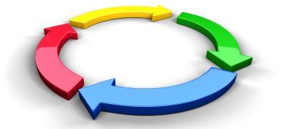

- Define Behavior
- What specific action has occurred?

- Determine Function
- What is the student attempting to avoid, ignore, escape, etc. through this specific action?

- Antecedent Strategies
- What occurred prior to the specific action occurring?

- Consequence Strategies
- Does the consequence “fit” the action?
- Are the consequences consistent?
- Are the consequences enforceable?

- Review data collected
- If there is not a positive effect on the targeted behavior, review the plan’s implementation

- Evaluate the Plan
- A plan is only as good as the individual(s) who are implementing the plan.

Interacting Positively: Building Relationships
“Someone’s destiny is tied to your assignment.” - Ole Pete Key
You must know your students and establish positive relationships with each of them.
- Who are they?
- What’s their story?
How can I connect to the student’s parent and family members?
- Show an interest in your students by:
  - Call your students by their name.
  - Know what they are interested in.
  - Attend school events...sports, plays, concerts, etc.
  - Contact parents with “good news”, do not just call when things are not going well.
  - If possible, visit your student’s home. Always ask for an “invitation” to visit. You do not have to go inside, a visit on the porch or in the front yard is just as effective.
Meeting Norms
Meeting norms are a set of team-created rules or guidelines that help to shape the interaction with one another during meetings. Listed below are examples of meeting norms used in the Tuscaloosa City School System.
- Student Achievement is our top priority
- Always be professional and respectful
- Open-minded discussion where everyone has input
- Staying on schedule is everyone’s responsibility
- Keep comments brief and to the point
- Ask what’s possible not what’s wrong
- Thinking is solution-driven
- Clear takeaways and follow through
- Put phones on vibrate
- Keep electronics use to a minimum

Faculty Training

The PBIS framework supports teachers and administrators to manage behavior and attendance with consistency. The LEA should ensure that all school personnel are trained annually in PBIS. During the summer, district personnel should train all school administrators on the following topics:
- PBIS
- Expectations and goals for discipline
- Code of Conduct violations and consequences
- Due Process
- Suspension and Expulsion process and documentation
- SIR computer reporting
- Impact of Attendance
The school administrator should train its staff during the summer before students arrive on campus on the following topics:
- PBIS
- School-wide behavior expectations (tier I - universal strategy)
- Classroom behavior expectations
- Office-handled vs classroom-handled behaviors
- Classroom management strategies
- Office Discipline Referral (ODR) process and documentation
- Restorative practices
- Anti-Bullying Program
- Suicide Prevention
- Attendance

A school-wide discipline plan is the Tier I universal intervention. It is designed to address school goals, teach the expected behaviors to students, and provide teachers with a framework to handle discipline. To reinforce the expectations, the behaviors should be posted, taught, modeled, practiced, observed, retaught, and rewarded. In this way, students are taught in their learning style of visual, auditory, or kinesthetic. The school-wide expectations provide a framework for consistency in improving the school climate. Here are some examples of school-wide expectations:
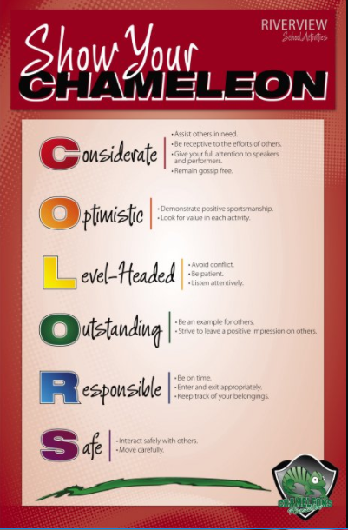
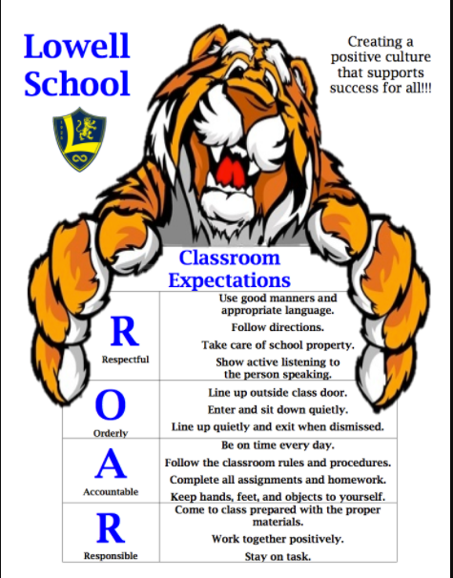

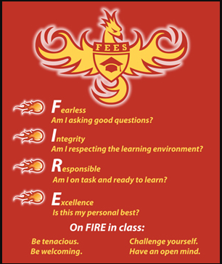

Notice that the school-wide behavior expectations are simplistic and easy to remember. Some schools create a behavior matrix to apply the school wide behavior expectations to various parts of the school. The matrix provides consistent language for staff to use to define behaviors. In each area, expected behaviors are posted, taught, modeled, practiced, and observed. The teacher provides specific directions about the rules, routines, and procedures for that particular area. In this way, students understand the different behavior expectations and can refer to them when necessary. Here are some examples:

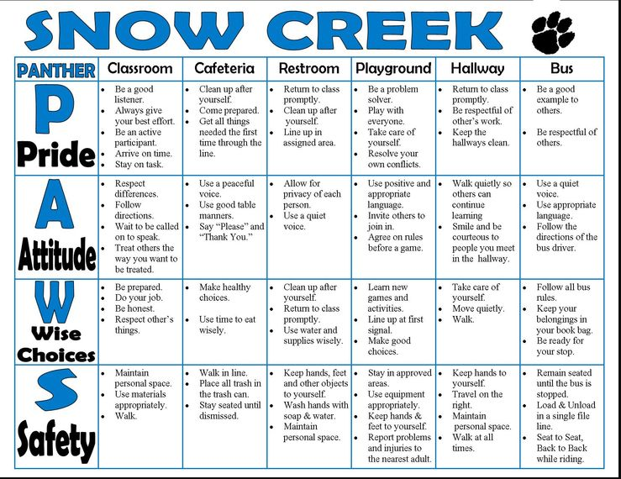
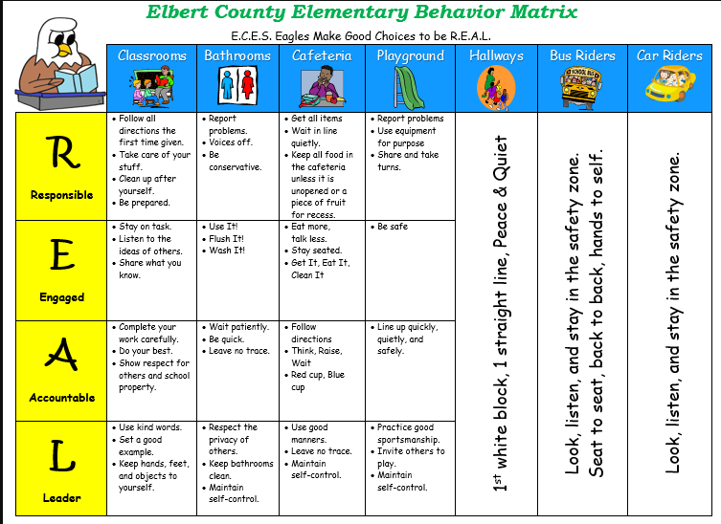

The behavior matrix allows the school to define the behavior expectations for students and describe minor behavior issues for teachers. When students have been redirected repeatedly or if the behavior is outside of expected behavior, then further action may be necessary.

A. Office Discipline Referrals (ODR)
An ODR is completed when a student exhibits behaviors that cause a major disruption, pose a safety concern, or are unlawful. School administrators should clearly define what behaviors constitute an office discipline referral with teachers before school starts. If the behavior is repetitive or minor behavior, the teacher should use progressive discipline to include contacting the parent and a classroom intervention before a referral is written. If the behavior is severe enough to warrant an ODR, the school administrators should ensure that due process is given. The student will:
- Know what rule was violated (Code of Conduct violation)
- Know the evidence against them (ODR form and witness statements)
- Be given the opportunity to explain what occurred (Written statement)

Directions for completing an ODR:
The teacher must follow all outlined procedures and documentation prior to sending a child to the office. The ODR form should include the time, date, location of the incident, along with a brief, but detailed description of the facts of what occurred. The administrator will use the Code of Conduct to decide:
- Whether to consider it as an office referral or return the student to class
- What classification to assign
- What consequence to assign
Figure 1 shows the flowchart of what behaviors should be handled by the classroom teacher and which behaviors should be handled by an administrator.

Figure 1. Problem Solving Flowchart (Horner, Nese, 2014)
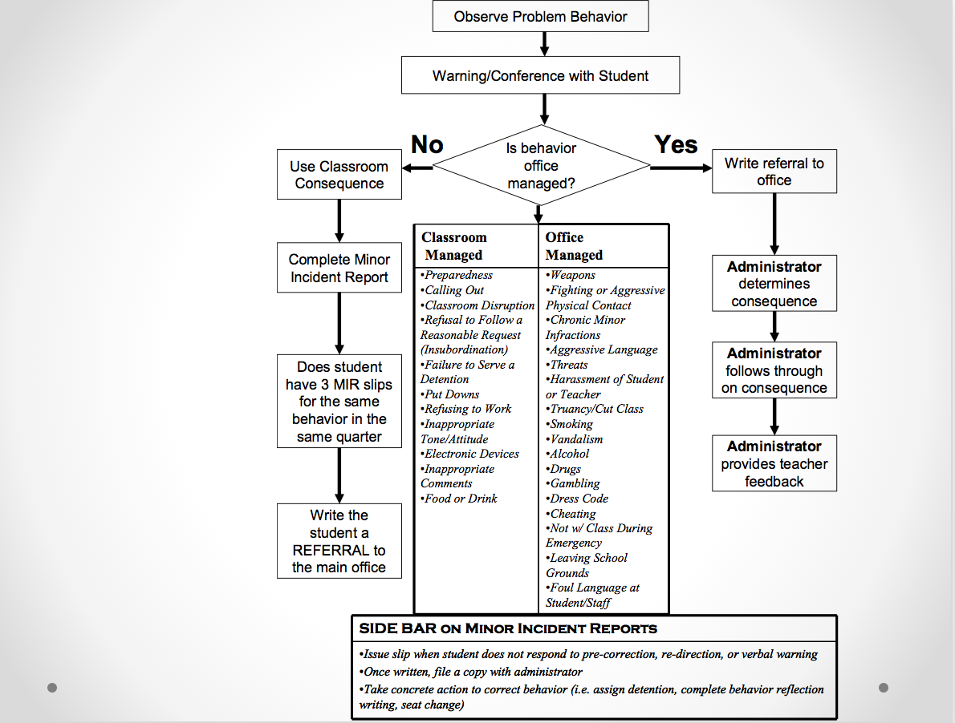

B. Minor Infraction Definitions - Classroom Managed
Teachers can reduce the amount of classroom behavior problems by implementing a proactive approach. By following the steps listed below, the teacher is more likely to handle classroom behaviors before they become an issue.
- Build a positive relationship with each student
- Post, review, and refer to behavior expectations
- Create a daily agenda/routine
- Create the physical learning environment to meet student needs

If students violate one of the behavior expectations, the teacher should implement a classroom intervention that:
- preserves the dignity of the student
- corrects student in private rather than in public
- responds consistently and fair
- identifies the cause of the misbehavior (Savage & Savage 2010).

If the behavior continues over time or escalates, then an ODR may be necessary. School administrators should determine the repetitiveness of a minor behavior to necessitate an ODR. Common minor infractions are listed in Figure 2. These violations are not serious in nature and should be handled by the classroom teacher. The most common minor infraction is disrespect and the biggest mistake classroom teachers make is taking disrespectful behavior personally (Linson, 2009). Because disrespect is subjective, the teacher typically responds by challenging the student which creates a power struggle or the teacher will punish unnecessarily which undermines and damages the teacher-student relationship. Reacting out of anger leads to the student being backed in a corner. Instead, the teacher should follow the school-wide discipline plan and enforce a classroom consequence. This reinforces the behavior expectations and ensures consistency in the classroom.

Figure 2: Minor Infractions from School-Wide Information System (SWIS)
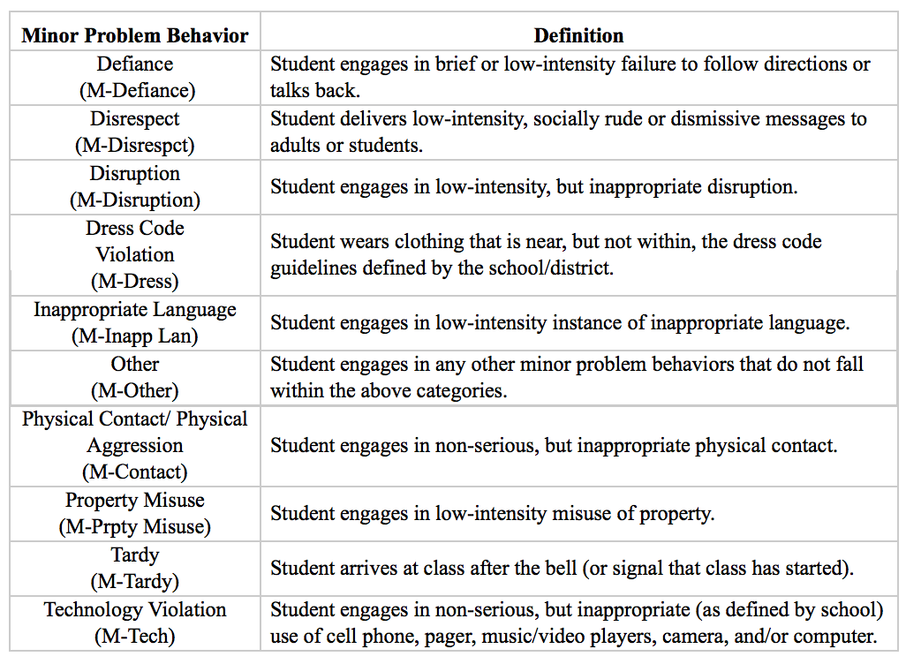
Teachers should work through the following questions in order to address behavior causes instead of reacting to behavior outbursts:
- What is the problem?
Behaviors can be addressed by the teacher asking one simple question, “What’s wrong?” This strengthens the teacher-student relationship and shows concern for the student instead of immediately addressing the behavior. This question prompts the student to explain what is happening so that the teacher can address it. Although the reason may seem simple or minor to the teacher, it may be necessary for the teacher to address so that the student feels safe.
- Why is it happening?
Is the student upset? Sleepy? Hungry? Worried? Anxious? While most minor behaviors can be redirected with non-verbal cues, others require an explanation from the student. Again, the simple question of “Are you okay?” will provide the teacher with information on how to help the student. If the teacher can understand what causes the behavior, then the teacher will be able to address the issue before it causes the student to act inappropriately.

- How do I solve the problem?
After the teacher understands what the student’ behavior is and what has caused it, he or she must then determine how to appropriately handle the situation. Minor behaviors can be corrected with non-verbal cues such as proximity, eye contact, gestures, and also with verbal reminders referring to the rules/expectations or praise of students demonstrating expected behavior. If the student does not respond, then try another logical consequence or intervention strategy.

- Did the intervention work?
If the classroom teacher has exhausted interventions and strategies, the continued behavior may result in an ODR. Follow the tiered intervention framework to try and correct behavior. The student may end up in Tier III intervention needing additional resources such as:
- anger management counseling/strategies
- alternatives to suspension
- restorative practices
- special education referral
- behavioral therapist intervention
- multi-disciplinary team referral
- mental health referral

Resources:
Linson, M. (2009). How to Handle Disrespectful Students. https://www.smartclassroommanagement.com/2009/07/31/how-to-handle-disrespectful-students/
Savage, T. & Savage, M. (2010). Successful classroom management and discipline: teaching self-control and responsibility (3rd ed.). Los Angeles: Sage.

C. Major Infraction Definitions
All violations should be clearly defined in the Code of Conduct; however, certain violations must be reported to the SDE as SIR infractions. If the student behavior falls outside of the outlined classroom managed behaviors, the teacher should ensure the safety of the students involved and complete an ODR. After the teacher completes the ODR form, the administrator should begin the investigation. Once all witness statements are reviewed, a violation must be determined. Administrators should match the description of the behavior with a violation. If the behavior does not constitute a violation, the student should be returned to class. LEAs and school administrators should be clear on when a student will be removed from the learning environment and how the learning lost will be restored. If the behavior constitutes a violation, the administrator should follow the guidelines outlined in the Code of Conduct. Figure 3 is a list of all infractions that must be reported to the SDE and will be included in the SIR report.

Figure 3: SIR Infractions
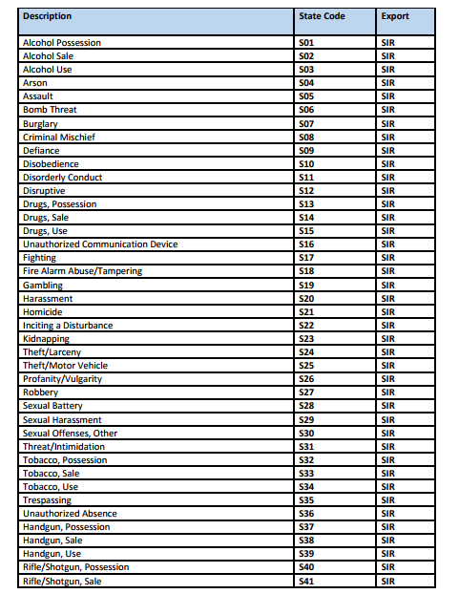
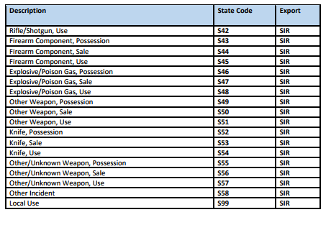
Typically, LEAs will include additional infractions and provide a list of minor, intermediate, and major violations. Consequences in the Code of Conduct will reflect the type of infraction. For example, a minor infraction of failure to follow directions will have a minor consequence of verbal reprimand whereas knife use may result in expulsion. For non-violent major infractions, consider using in-school suspension. Expulsion and out-of-school suspension should be reserved for the unlawful or more violent offenses.

Resources:
Classroom
http://www.pbis.org/common/cms/files/pbisresources/Supporting%20and%20Responding%20to%20Behavior.pdf
SIR Manual: https://www.alsde.edu/sec/pss/Discipline/SIR%20Overview%20and%20Summary.pdf

Commonly Used Infractions, Their Definitions from SIR, and Misconceptions
1. Assault as a Major Infraction in SIR
“An actual and intentional touching or striking of another person against his or her will or intentionally causing bodily harm to an individual. When one individual physically attacks or “beats up on” another individual. Includes an attack with a weapon or one that causes serious bodily harm to the victim. This category should be used only when the attack is very serious. Administrators need to consider age and developmentally appropriate behavior before using this category. This category refers to an individual who harms another person as follows:
- With intent to disfigure another person seriously and permanently or to destroy, amputate, or disable permanently a member or organ of his/her body, he/she causes such an injury to any person.
- Under circumstances manifesting extreme indifference to the value of human life, he/she recklessly engages in conduct that creates a grave risk of death to another person and thereby causes serious physical injury to any person.
- In the course of and in furtherance of the commission or attempted commission of arson, burglary, escape, kidnapping, rape, robbery, sodomy, or any other felony clearly dangerous to human life, or of immediate flight therefrom, he/she causes a serious physical injury to another person.
- While driving under the influence of alcohol or a controlled substance, or any combination thereof, he/she causes serious bodily injury to the person of another with a motor vehicle.
- With intent to cause physical injury to another person, he/she causes serious physical injury to any person by means of a deadly weapon or an instrument.
- With intent to cause serious physical injury to a teacher or to an employee of a public education institution during or as a result of the performance of his or her duty, he/she causes physical injury to any person.
- For purposes other than lawful medical or therapeutic treatment, he/she intentionally causes stupor, unconsciousness, or other physical or mental impairment or injury to another person by administering to him or her, without his or her consent, a drug, substance, or preparation capable of producing the intended harm.
- With intent to cause physical injury to another person, he/she causes physical injury to any person.
- With intent to prevent a peace officer, emergency medical personnel, or a firefighter from performing a lawful duty, he/she intends to cause serious physical injury and he/she causes serious physical injury to any person.
- He/she recklessly causes physical injury to another person by means of a deadly weapon or dangerous instrument.
KEY WORD(S): serious bodily injury

2. Defiance of Authority as a Major Infraction (SIR)
“Willful disobedience of a direct order of instruction from a school board employee or others having legal authority. A contemptuous opposition or disregard of an order of instruction from a school board employee or others having legal authority (policeman, fireman) openly expressed in words or actions. This conduct substantially disrupts the orderly conduct of a school function or is behavior that substantially disrupts the orderly learning environment or poses a threat to the health, safety, and/or welfare of students, staff, or others.”
KEY WORD(S): substantially disrupts

3. Disruptive Demonstrations as a Major Infraction (SIR)
“Demonstrations consist of five or more participants who, in a course of a demonstration, are likely to cause substantial harm or serious inconvenience, annoyance, or alarm, and intentionally refuse or fail to disperse when ordered to do so by an authorized school official, peace officer, or other public servant lawfully engaged in executing or enforcing the law. The demonstration substantially disrupts the orderly conduct of a school function or substantially disrupts the orderly learning environment or poses a threat to the health, safety, and/or welfare of students, staff, or others.”
KEY WORD(S): five or more participants

Persistent, Willful Disobedience
“Reoccurring, intentional violation of the code of student conduct as determined by the school administrator which substantially disrupts the orderly conduct of a school function, behavior which substantially disrupts the orderly learning environment, or poses a threat to the health, safety, and/or welfare of students, staff, or others.”
KEY WORD(S): intentional and substantially disrupts

4. Disorderly Conduct as Major Infraction in SIR (serious class or campus disruption, etc.).
“Any act which substantially disrupts the orderly conduct of a school function or which substantially disrupts the orderly learning environment or poses a threat to the health, safety, and/or welfare of students, staff, or others. If the action results in a more serious incident, report in the more serious incident category. This category does not include fights. This category includes an individual who: Makes unreasonable noise. In a public place uses abusive or obscene language or makes an obscene gesture. Without lawful authority, disturbs any lawful assembly or meeting of persons.”
KEY WORD(S): serious class/campus disruption

5. Harassment (Note: Bullying should be reported here.)
“A continuous pattern of intentional behavior that takes place on school property, on a school bus, or at a school-sponsored function including, but not limited to, written, electronic, verbal, or physical acts that are reasonably perceived as being motivated by any characteristic of a student, or by the association of a student with an individual who has a particular characteristic, if the characteristic falls into one of the categories of personal characteristics contained in the model policy adopted by the department or by a local board. To constitute harassment, a pattern of behavior may do any of the following:

- Place a student in reasonable fear of harm to his or her person or damage to his or her property.
- Have the effect of substantially interfering with the educational performance, opportunities, or benefits of a student.
- Have the effect of substantially disrupting or interfering with the orderly operation of the school.
- Have the effect of creating a hostile environment in the school, on school property, on a school bus, or at a school-sponsored function.
- Have the effect of being sufficiently severe, persistent, or pervasive enough to create an intimidating, threatening, or abusive educational environment for a student.

A person commits the act of harassment if with intent to harass, annoy, intimidate, or alarm another person, either socially, physically, or emotionally, he/she:
- Strikes, shoves, kicks, or otherwise touches a person or subjects him to physical contact.
- Directs abusive or obscene language or makes an obscene gesture towards another person. A person commits the crime of harassing communication if, with intent to harass or alarm another person, he/she: Communicates with a person, anonymously or otherwise, by telephone, telegraph, mail, or any other form of written or electronic communication in a manner likely to harass or cause alarm. Makes a telephone call, whether or not a conversation ensues, with no purpose of legitimate communication. Telephones another person and addresses to or about such other person any lewd or obscene words or language. This includes a threat, verbal or nonverbal, made with intent to carry out the threat that would cause a reasonable person who is the target of the threat to fear for his or her safety. Bullying would be reported under this category.”
KEY WORD(S): pattern of behavior

6. Fighting
“Mutual participation in a fight involving physical violence where there are at least two participants, but no one main offender and no major injury. Fighting does not include verbal confrontations, tussles, or other minor confrontations. This conduct creates a substantial risk of serious physical injury to another person. Administrators need to consider age and developmentally appropriate behavior before using this category. See also Assault, Harassment, and/or other applicable terms.”
KEY WORD(S): mutual participation and at least two participants

7. Other Incidents Resulting in a State defined Disciplinary Action
- This category is not defined and its use should be limited.

8. Disrespect
- This is not a SIR category and unless a behavior meets the definition of a different code, should not be used as a major infraction code.

Bullying

Alabama is one of 41 states that has adopted an anti-bullying policy and law to convey the message that the effects of bullying are detrimental to students. LEAs should adopt a policy and procedure for handling bullying incidents.
- Before bullying occurs (prevention) = training
  - LEA should train administrators in the Board approved policy, the reporting documentation, and procedure for handling bullying
  - School administrators should train teachers on the following topics:
    - Definition of bullying
    - School policy and procedure on how to handle bullying
    - Warning signs and risk factors
    - Participants (perpetrator, victim, and bystander)
  - Teachers should teach students:
    - What bullying is and is not
    - What to do if you are being bullied
    - What to do if you witness bullying
LEAs should also ensure that parents know the policy and procedure and have the ability
to report bullying to the school.

- During a bullying incident (intervention) - how to help
  - LEA should identify how adults should intervene and support the participants
    - support the victim by listening and ensuring safety
    - address the bullying behavior by teaching expectations and providing consequences
    - support the bystanders by encouraging them to report what they see and intervene

- After (follow up) = treatment
  - Schools should ensure that students have access to counseling
  - Administrators provide alternatives for behavior for victim and perpetrator

- Review Appendix B: Bullying Prevention Checklist

Resources:
National PBIS Center on Bullying:
http://www.pbis.org/school/bully-prevention

Suicide Prevention

The Jason Flatt Act is in 19 states in the U.S. and Alabama passed the legislation in 2016. It requires all teachers to complete annual training in youth suicide awareness and prevention specifically to know the warning signs, risk factors, and procedure for when a student has suicidal thoughts or ideation. Because suicide is the 2nd leading cause of death in youth ages 10-24, there is no time to delay. Schools and communities must address the problem together. LEAs should ensure the following:
- The district has formally adopted a policy.
- The district provides training for all teachers, counselors, social workers, nurses, and school administrators on the referral process.
- The school provides training for students.
- The district and school work with parents and the community to establish partnerships providing resources for students.
The resources below contain model policies, school protocols, training videos, quizzes, apps for phones and more.

Resources:
The Jason Flatt Foundation: http://jasonfoundation.com/
Peer Helpers - Jason Flatt Act resources: http://jennifermoorefoundation.com/
Alabama Suicide Prevention and Resources Coalition: https://www.asparc.org/

Summary
The ALSDE is dedicated to improving the outcomes for all students. This requires a planned and integrated focus to address behavior and academic performance. This guidebook outlines a proactive, preventative approach framed in PBIS that integrates bullying prevention and suicide prevention to achieve these improved outcomes. Research indicates that if PBIS and restorative practices are implemented to fidelity, the following measurable outcomes are possible:
- improved school climate
- decreased discipline
- increase attendance
- increase graduation rates
- improved teacher satisfaction

Juvenile Justice and SRO

Zero tolerance policies not only have a negative impact on students but are putting an undue burden on the Juvenile Justice System. The Juvenile Justice System as a whole is often unable to provide the “sole services” to clients that are referred to them by educators. Building a support system and understanding effective use of community resources through targeted interventions is the most effective manner to build a safe, positive climate and prioritize a child’s education. The ultimate goal of keeping children in school and out of the Juvenile Justice System should be a priority. Effective educators should dig beyond a student’s “displayed behavior” to bring emotional and physical support which can strengthen academic endeavors. Too often components of the Juvenile Justice System are used as a punitive measure rather than informational, preemptive, and life strengthening as a means to positively affect a child’s school experience. The following resources should guide you in developing partnerships and resources to promote student success.

What is a School Resource Officer?
A school resource officer, by federal definition, is a career law enforcement officer with sworn authority who is deployed by an employing police department or agency in a community-oriented policing assignment to work in collaboration with one or more schools.

The Alabama Association of School Resource Officers (TAASRO) Definition of School Resource Officer: An APOSTC law enforcement officer under the direction of a law enforcement agency who is specifically selected and specially trained for the school setting.

Alabama Requirements to be a School Resource Officer (SRO)
- APOSTC certification
- Active shooter response training (alert Alabama emergency rapid response training)
- Less than lethal training
- Verification of annual firearm training
Additional requirement recommendations:
- MOU between school system and law enforcement agency
- SROs should be specifically selected to ensure the best fit for the school environment
- SROs should be properly trained
  - Best Practice – NASRO training – 40 hour class, one week class
    - Community Oriented Policing Services (COPS) has scholarships
  - The Alabama Association School Resources Officers (TAASRO) – annual education conference (week-long conference in Gulf Shores)

Role of SROs:
The role of the SRO is to actively provide a safe school environment that is conducive to learning. Below are some examples of how this can be achieved. While this list serves as a guideline it is not all-inclusive.
- Provides an assisting resource to school administration.
- Aids in developing school emergency operation plans.
- Is a liaison between school system and local law enforcement and other first responders.
- Supports school order, without having a punitive assignment role.
- Builds positive relationships with all school personnel, students and families. This is a key component.
- Creates rapport and trust with students.
- Promotes prevention and intervention
- De-escalates situations and help with resolutions.
- Acts as a Mentor/Motivator
- Educates youth on laws and other personal safety concerns.
- Provides life guidance.
- Promotes good decision making.
- Is involved in extracurricular and athletic school events.
- Attends PTO and Parent Education events.

SRO’s techniques and interventions for children
- Identify possible underlying reasons for disruptive behavior? (Examples: trauma, child abuse, hunger, parent deployment, mental illness)
- De-escalation techniques (Example: Are you ok? How can I help you?)
  - Tone of voice
  - Mannerisms
  - Being seated instead of standing
- Identify possible resolutions to the problem?

Memorandum of Understanding
A memorandum of understanding (MOU) is an agreement between two or more parties. It expresses a convergence of will between the parties, indicating an intended common line of action. It is often used in cases where parties either do not imply a legal commitment or in situations where the parties cannot create a legally enforceable agreement. Memorandum of Understanding’s (MOU) play a key role in defining the roles and responsibilities of the school system and law enforcement agency.

The Community Oriented Policing Services and U.S. Department of Justice put together a fact sheet to assist in creating MOU’s.
https://nasro.org/cms/wp-content/uploads/2014/10/2013_MOU-FactSheet_v2_091613.pdf
Sample MOU’s:
https://nasro.org/cms/wp-content/uploads/2016/01/MOUsampleA2012.pdf
https://nasro.org/cms/wp-content/uploads/2016/01/MOUsampleB2012.pdf
https://nasro.org/cms/wp-content/uploads/2016/01/MOUsampleC2012.pdf

Utilizing the Juvenile Justice System
When referring children to the Juvenile Justice System, prior history, severity of the offense and incident circumstances should be carefully considered to insure appropriateness of the referral and ensure school safety.

What constitutes court referral?
- Referrals should be rare in nature. Understandably there will be circumstances where a court referral is necessary as required by specific laws and ordinances or incidents that jeopardize the safety of the school climate and/or individual welfare.
- Schools should utilize all resources possible to avoid court referrals.
- Administrators should exercise discretion and judgement in looking at what is an excused vs. unexcused absence when addressing truancy.
  - An early warning referral can be made after five (5) unexcused absences.
  - A petition can be filed after seven (7) unexcused absences.
Recommendations on how to decide if a situation constitutes a court referral:
- Consider the community standard.
- Consider behaviors and intent of child. Training should be provided for educators and law enforcement on this topic.

Zero tolerance policies should be removed to avoid the unnecessary early entry of children into the Juvenile Justice System.

Notice by the Court and Readmission to Schools
A. PLACEMENT
1. NOTICE BY THE COURT
Notwithstanding subsection (a) of Section 12-15-133, written notice that a child enrolled in a school, Kindergarten to Grade 12, has been found delinquent of an act which if committed by an adult would be a Class A or B felony or any other crime, at the discretion of the juvenile court, shall be provided within seven days to the superintendent of the school district of attendance, or, if the child attends a private school, to the principal of the school. The juvenile court shall provide the notice using whatever method it deems appropriate or otherwise as decided by the Administrative Office of Courts. The prosecutor may recommend to the juvenile court that notice be given to the school for any delinquent act. Written notice shall include only the offenses, enumerated by the appropriate code section and brief description, found to have been committed by the child and the disposition of the case involving the child. Where applicable, this notice shall be expeditiously transmitted by the district superintendent to the principal at the school of attendance. The principal shall disseminate the information to those counselors directly supervising or reporting on the behavior or progress of the child. In addition, the principal may disseminate the information to any teacher, administrator, or other school employee directly supervising or reporting on the behavior or progress of the child whom the principal believes needs the information to work with the pupil in appropriate fashion or to protect other students and staff.
Authority: Code of Alabama (1975) §12-15-217

B. READMISSION TO SCHOOL
1. AFTER COMPLETION OF SENTENCE
Any person determined to be guilty of an offense involving drugs, alcohol, weapons, physical harm to a person, or threatened physical harm to a person may be readmitted to the public schools of this state upon such conditions as the local board of education shall prescribe for preservation of the safety or security of students and employees of the local school board, which may include, but are not limited to, psychiatric or psychological evaluation and counseling.
Authority: Code of Alabama (1975) §16-1-24.1(d)

2. AFTER CONVICTION, BUT NOT SENTENCED TO IMPRISONMENT
Prior to the enactment of the Alabama Juvenile Justice Act of 2008, the Code of Alabama, 1975, required that several broad categories of children be placed in alternative schools by operation of law. See Code of Alabama, 1975, § 12-15-71(k) – (o) (2008). The 2008 Act deleted those sections, thereby restoring the discretion of local school boards to determine the appropriate educational setting and placement of students on an individualized basis, as required by federal law. See 20 U.S.C. §1414(d) (2008); 20 U.S.C. §1412(a)(5)(B) (2008).
Authority: Code of Alabama (1975) §12-15-215 (Guidance 79)

Resources In Lieu of Adjudications
- Formal Counseling
- Parenting Education/Classes
- Mentoring Programs
- Community Service
- Day/Evening Reporting Center
- Special Programing Achievement Network
- Use of Diversion Programs
  - Early Warning
  - Drug, Mental Health or Teen Court
Development of new diversion program based on local need and resources

Community Collaboration and Partnerships
Building relationships between the school, family, law enforcement and community partners ensures educational and social success for children. The goal of these partnerships is to reduce behavior issues and referrals to the Juvenile Justice System.

Building collaboration
- Define the vision and objectives of the partnership
- Ensure open and clear communication between partners
  - School system must be open to initiating contact with community partners.
- Understanding and accessing current community services
- Understanding the local community needs
  - Children’s Policy Council Needs Assessment
- Continual recruitment of new partnerships
- Maintaining diverse representation and involvement from all parts of the community
- Understand community funding sources
- Sharing resources to meet common goal

Building partnerships:
- Maintain constant communication and training between partners
- Establish Memorandums Of Understanding
- Effective utilization of pass-through funds
- Maintain continuity

Possible Partners/Resources/Services:
- 4-H
- Alabama National Drug Counter Drug Program
- Alabama Parent Education Center
- Anti-Drug Education
- Big Brothers Big Sisters
- Boy Scouts/Explorers
- Boys & Girls Club
- Chamber of Commerce
- Civic Organizations
- David Mathews Center for Civic Life
- DHR/Child Labor
- Easter Seals
- Faith Based
- Family Resource Centers
- First Responders
- Food Banks
- Girl Scouts
- Health Department
- Higher Education
- Hospice/Grief Support
- Juvenile Court
- Law Enforcement
- Local Children’s Policy Council
- Local Education Foundations
- Local Multi-Needs Teams
- Mental Health
- Mentoring Programs
- Military Family Assistance Centers
- Parks and Recreation
- PTO/PTA
- Shelters (Protective and Homeless)
- Sororities and Fraternities
- Substance Abuse Treatment Providers
- United Way
- Victims Compensation
- YMCA

State Resources:
- Alabama Department of Education Department of Prevention and Support
- Children’s Policy Council Resource Directory
- Department of Human Resources
- Department of Labor
- Department of Mental Health
- Helping Families Initiative
- Military Family Resources
- The Alabama Association of School Resource Officers (TAASRO)

National Resources:
- Blueprints for Healthy Youth Development – research based programs models. This program is through University of Colorado at Boulder. For more information visit http://www.colorado.edu/cspv/blueprints/
- Futures without Violence
- National Association of School Resource Officers (NASRO)

Extracurricular Activities, Sports & Arts

Extracurricular IS Co-Curricular
“Extracurriculars, our work suggests, tend to differ from core classes in a number of important ways. They are voluntary rather than mandatory; they often involve work that is undertaken collectively rather than individually; they feature opportunities for peer leadership and peer-to-peer learning; they involve dimensions of playfulness; and they are aligned to activities that are valued in broader American culture. As a result, these learning spaces take on a sense of purpose and vitality that all too often is missing from normal disciplinary classes.” (Jal Mehta, Sarah Fine, Harvard School of Education)

Why Bother with Extracurricular Activities?
- Because it is our job to develop the whole child.
- Because it is our job to provide a safe environment for each child in your care.
- Because state and federal mandates (ALSDE Alabama Ascending Plan) require that we decrease truancy, decrease number of office referrals, decrease school suspensions, decrease number of bullying incidents and increase community partnerships.
- Because we chose education - to “make a difference”.

What Does the Research Say?
Multiple research studies have confirmed the benefits of extracurricular activities:
- Decreased teen pregnancies
- Decreased office referrals
- Decreased school suspensions
- Decreased drug and alcohol use
- Increased academic achievement
- Increased time management skills
- Superior work force employees
- Develop service-oriented mindsets
- Develop higher level social skills and interaction skills

Supporting Research
- Our findings were clear cut. SAFE (Step-by-step learning; Active learning; Focused time and attention; Explicit in defining skills being taught) programs were associated with significant improvements in self-perceptions, school bonding and positive social behaviors; significant reductions in conduct problems and drug use; and significant increases in achievement test scores, grades and school attendance.”
(Durlak and Weissberg, 2011)
- “The Women’s Sports Foundation Report: Sport and Teen Pregnancy has uncovered a pattern of evidence that participation in sports helps many girls to make decisions about sexual activity that can prevent teen pregnancy. Our findings show that girls who play sports do in fact report lower pregnancy rates, engage in sexual intercourse less frequently, have fewer partners, and begin sexual activity later than those not involved with sports.
(https://www.womenssportsfoundation.org/research/article-and-report/health-research/sport-and-teen-pregnancy/)

- “When I advise people to seek and hire athletes, what I am really referring to is the athlete traits (akin to leadership traits) that make any individual an exceptional hire.”
(https://www.forbes.com/sites/davidkwilliams/2013/10/02/why-you-should-fill-your-company-with-athletes/)

- “Creative extracurricular activities such as music, dance, drama, and visual arts can increase participants’ self-confidence, self-esteem, and positive behaviors.” (Bungay 2013)

Influences of Extracurricular Activities

Resiliency
Resilience is your ability to adapt well and recover quickly after stress, adversity, trauma or tragedy.
The single most common factor for children who develop resilience is at least one stable and committed relationship with a supportive parent, caregiver, or other adult.
Center on the Developing Child, Harvard University

Bottom Line #1:
Young people live up or down to expectations we set for them. They need adults who believe in them unconditionally and hold them to the high expectations of being compassionate, generous, and creative.
Bottom Line #2:
What we do to model healthy resilience strategies for our children is more important than anything we say about them.

The Essential 2 Questions for our Schools:
- Within our walls, do we believe in every young person unconditionally and hold them to high expectations?
- Do we sincerely believe that every child can succeed?

The 7 Cs: The Essential Building Blocks of Resilience
Competence: When we notice what young people are doing right and give them opportunities to develop important skills, they feel competent. We undermine competence when we don't allow young people to recover themselves after a fall.

Confidence: Young people need confidence to be able to navigate the world, think outside the box, and recover from challenges.

Connection: Connections with other people, schools, and communities offer young people the security that allows them to stand on their own and develop creative solutions.

Character: Young people need a clear sense of right and wrong and a commitment to integrity.

Contribution: Young people who contribute to the well-being of others will receive gratitude rather than condemnation. They will learn that contributing feels good and may therefore more easily turn to others, and do so without shame.

Coping: Young people who possess a variety of healthy coping strategies will be less likely to turn to dangerous quick fixes when stressed.

Control: Young people who understand that privileges and respect are earned through demonstrated responsibility will learn to make wise choices and feel a sense of control.

Research-based questions for educators to consider:
Ginsburg, Kenneth, MD, MS Ed, FAAP, excerpt from Building Resilience in Children and Teens, November, 2015, Healthy Children Magazine, healthychildren.org

Competence
- Do we see what a young person has done right? Or do we focus on his/her mistakes?
- Do we help our youth recognize what they have going for themselves?
- Do we help them focus on those strengths and build upon them?
- Are we helping to build the authentic skills that make them competent in the real world?
Educational Skills
Social Skills
Anger Management Skills
Work Skills
Interview Skills
Stress Reduction Skills
- Do we communicate in a way that empowers them to make their own decisions, or do we undermine their sense of competence by lecturing them thereby giving them information in a style they cannot grasp? Rather than talking down to them, do we instead deliver information in a manner they understand?
- Do we let them make safe mistakes so they have the opportunity to right themselves . . . or do we protect them from every bump and bruise?
- Do we praise in a way that notices effort more than it rewards the product?
Confidence
- Do we see the best in our youth so that they can see the best in themselves?
- Do we clearly express that we expect the best in them?
- Do we help them recognize what they have done right? (Confidence comes from knowing that one has competence.)
- Do we help them understand that they have authentic survival skills?
- Do we treat them as incapable children or young adults learning to navigate a difficult world?
- Do we catch them when they are doing the right thing?
- Do we encourage them to strive just a little bit further because we believe they can succeed?
- Do we avoid instilling shame?
Connection
- Do we recognize that adults' unconditional belief in a young person— and holding them to high expectations—is the single most important factor determining whether they will be able to overcome challenging circumstances?
- Do we enter young people’s lives without permission, or do we give them time to understand we are worthy of their trust?
- Do we build a sense of safe community within our walls?
- Do we encourage young people to take pride in the various ethnic, religious, or cultural groups they belong to?
- Do we recognize that for many of our most troubled youth, the firm attachment to a stable family might be missing? Further, do we know that our role as stable caring adults takes on an even greater importance?
- Do we have a TV and self-contained entertainment system in every room, or do we create a common space so people share time together? Does everyone exist in their own world hiding behind earphones, and texting distant friends, or is communication happening here?

Character
- Are we helping them to recognize themselves as caring people?
- Do we allow them to clarify their own values?
- Do we allow them to consider right versus wrong and look beyond immediate needs?
- Do we help them understand how their behavior affects others?
- Do we help them develop a sense of spirituality that fits into their (not our) belief system?
- Do we value them so clearly that we model for them how important it is to care for others?
- Do we value each other so clearly that we demonstrate the importance of community?
- Do we value each young person, and promote the understanding that when all reach their potential, every child benefits?
Contribution
- Do we make clear that we believe our youth can make the world a better place?
- As we create programs that serve youth, do we include them in the planning process, appreciating that they are the experts on themselves and their own needs?
- Do we create opportunities for each youth to contribute to the community?
- Do we share how important a value it is to serve others?
- Do we help our young people recognize that precisely because they have come through difficult times they are positioned to guide others how to improve their lives?
- Do we search in each person’s life for another individual for whom they might serve as a role model? Do we use this to encourage them to be the best person they can possibly be?
- Do we help them to understand that if they have messed up in their past—their recovery serves as a model?
Coping
- Do we recognize that so many of the risk behaviors youth engage in are attempts at reducing the stress/pain in their lives?
- Do we condemn young people for their behaviors? Do we increase their sense of shame and therefore drive them toward those behaviors?
- Do we believe that telling youth to “just stop!” the negative behaviors will do any good?
- Do we guide youth to develop positive, effective coping strategies?
- Do we help young people understand when their thoughts are magnifying problems; do we help them to make realistic assessments?
- Do we model positive coping strategies on a daily basis?
- Do we encourage caring for our bodies through exercise, good nutrition, and adequate sleep?
- Does our community have resources where children can safely play and exercise either in the outdoors, or in recreational centers?
- Do we encourage creative expression? Does our community offer resources and programs where children and teens are able to learn and practice creative expression?
- Do we encourage written and verbal expression in a way that allows each youth to reveal thoughts in a comfortable manner, whether through talking, journaling, poetry or rap?
- Do we create an environment where talking, listening, and sharing is safe and productive?
- Do we model relaxation techniques?
- As we struggle to compose ourselves so we can make the fairest, wisest decisions, do we model how we take control rather than respond impulsively
Control
- Do we help young people understand that life is not purely random?
- Do we help them, on the other hand, to understand that they are not responsible for many of the bad circumstances that may have plagued them?
- Do we help them think about the future but take one step at a time?
- Do we help them recognize their mini-successes so they can experience the knowledge that they can succeed?
- Do we help youth understand that while no one can control all their circumstances each person can shift the odds by choosing positive or protective behaviors?
- Do we understand that youth who have been hurt emotionally or physically may think they have no control and therefore have no reason to take positive action?
- Do we understand that discipline is about teaching not punishing or controlling. Do we use discipline as a means to help someone understand that their actions produce consequences (i.e., life is not random)?
Ginsburg, Kenneth, MD, MS Ed, FAAP, excerpt from Building Resilience in Children and Teens, November, 2015, Healthy Children Magazine, healthychildren.org

How Do I Fund Extracurricular Activities?
- Local community-based organizations often offer sliding scale fees for families, and often waive fees altogether for families that need it.
- Grants (Local, State and Private):
Foundations: NFL, Mott Foundation, Jason Foundation, etc.
- Fundraising
- Local Businesses (Partners in Education)
- PTO/Alumni/etc.

“At a cost of only one to three percent (or less in many cases) of an overall school's budget, high school activity programs are one of today’s best bargains. It is in these vital programs – sports, music, speech, theatre, debate – where young people learn lifelong lessons that complement the academic lessons taught in the classroom. From a cost standpoint, activity programs are an exceptional bargain when matched against the overall school district’s education budget.” (NFHS)
Collaborations/Partnerships
What businesses and/or organizations are available in your community and within the school to help you create extracurricular opportunities for your students?
Consider These Options:
Internal Options for Collaboration:
- Teachers from varied disciplines (math, art, history, science, career tech, etc.)
- School Teachers and/or Staff with other talents and or hobbies (pottery, fishing, journaling, photography, culinary, etc.)
- Coaches with expertise in fitness (teach aerobics, elementary skill development, Pilates, etc.)
- Intramural sports offerings (bass fishing, lacrosse, sand volleyball, pickle ball, badminton, etc.)
- Club opportunities (Chess, robotics, computers, journalism, quilting, model cars, etc.)
- Create school-wide projects (i.e. Operas, plays, work days, service days, field day, etc.)

External Options for Collaboration:
- YMCA
- Boys & Girls Clubs
- Big Brothers Big Sisters
- City Parks & Recreation Department
- Young Professional Organizations
- Cooperative Extension Agencies
- Local Community Theatres
- Local and/or State Arts Councils
- Local Industry and/or Businesses (manufacturing, banks, car dealerships, Chick-Fil-A)
- State Work Force Consortiums
- Continuing Education Departments at colleges and universities, etc.

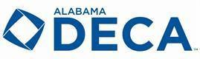
Prepares emerging leaders and entrepreneurs in marketing, finance, hospitality and management. There are over 215,000 members in chapters established in all fifty states and the District of Columbia, Canada, China, Germany, Guam, Mexico, Puerto Rico and Spain. Https://www.deca.org

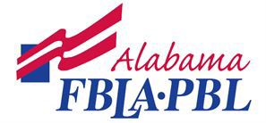
A nonprofit international career and technical student organization for young men and women preparing for careers in business and business-related fields. Our mission is to bring business and education together in a positive working relationship through innovative leadership and career development programs.www.fbla-pbl.org

Future Health Professionals is a student led organization which is 100% health focused and acts as a pipeline to provide seamless transition opportunities for members to move from education to career.

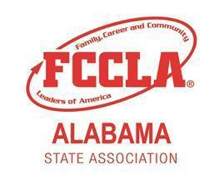
A nonprofit national career and technical student organization for young men and women in family and consumer sciences education in schools through grade 12. FCCLA is the ultimate leadership experience. Contact State Adviser.

FFA makes a positive difference in the lives of young people by developing their potential for premier leadership, personal growth, and career success through agri-science education.

Jobs for Alabama's Graduates (JAG) is a school-to-career program for at-risk high school youth, using a national model called Jobs for America's Graduates. JAG's mission is to keep young people in school and provide work-based learning experiences that will lead to career advancement opportunities or to enrollment in a postsecondary institution that leads them to a rewarding career.

SkillsUSA is a partnership of students, teachers and industry working together to ensure America has a skilled workforce. We provide educational programs, events and competitions that support career and technical education in the nation’s classrooms.

To promote the ideals of academic achievement, character, service and leadership among elementary and secondary school students.
ACHIEVEMENT - Recognizing and honoring high academic achievement CHARACTER - Preparing young people for life and empowering them to be successful
LEADERSHIP - Developing the leaders of tomorrow
SERVICE - Demonstrating our motto: Let Us Lead by Serving Others

An international, student-led organization that provides its members with opportunities to provide service, build character and develop leadership.

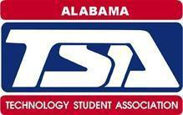
The Technology Student Association (TSA) fosters personal growth, leadership, and opportunities in Science, Technology, Engineering, and Mathematics (STEM); members apply and integrate these concepts through co-curricular activities, competitions, and related programs.

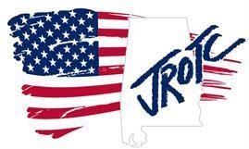
Junior Reserve Officer Training Corps (JROTC) is a program offered to high schools that teaches students character education, student achievement, wellness, leadership, and diversity. It is a cooperative effort between the military and the high schools to produce successful students and citizens, while fostering in each school a more constructive and disciplined learning environment. JROTC provides course-work on leadership, civics, geography and global awareness, health, and wellness, language arts, life skills, and U.S. history. The curriculum is based on the principles of performance-based, learner-centered education and promotes development of core abilities: capacity for life-long learning, communication, responsibility for actions and choices, good citizenship, respectful treatment of others, and critical thinking techniques.

Afterschool club for 6 - 12 grade girls to explore coding in a fun and friendly environment www.girlswhocode.comwww.code.org

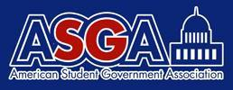
American Student Government Association (ASGA)

P: 1-877-ASK-ASGA (1-877-275-2742) | F: 352-373-8120 |
info@asgaonline.com

412 NW 16th Avenue, Gainesville, FL 32601-4203

Safe School Ambassadors® Program (SSA) http://www.optimist.org/default.cfm
http:\commmunity-matters.org
Phone: (707) 823-6159 Fax: (707) 823-3373

What is Needed for Extracurricular Activities to be Successful?

Three factors were identified as being critical to achieving positive youth outcomes:
1. Access to and sustained participation in the program
2. Quality programming and staffing
3. Strong partnerships among the program and other places where students are learning, such as their school, their homes, and other community institutions (Little, Wimer, and Weiss)

“People [students] Don’t Care How Much You Know, Until They Know How Much You Care”~ Theodore Roosevelt

How to Build Positive Student –Teacher Relationships

- Engage students in conversations about their personal interests.
- Provide support to students in their extra-curricular activities. (The ministry of being present)
- Provide opportunities to engage parents in conversations outside of normal school hours.
- Look for the positive and send notes to children and parents, etc. to let them know you see the positive.
- Be an advisor for a club.
- Participate in pep rallies. (Laugh at yourself)
- Teach life lessons; not just subject matter.
- Be sensitive to students’ home situation and life events.
- Hold students’ accountable.
- Recognize students’ full potential.
- Tell each and every student you love them - and mean it.

How to Build Positive Staff Relationships
- Invite other subject matter teachers to speak to your class about their subject matter.
- Send handwritten thank you notes.
- Invite faculty members, custodians, etc. to be the “Captain of the Week” for home athletic contests.
- Create planning periods where faculty from multiple disciplines are collaborating together to develop the holistic approach for the nurturing of each student.
- Attend other discipline’s activities (band concerts, art exhibits, car washes, athletic events, etc.)
- Recognize “Favorite Teachers” at events and have students/players stand with their favorite teacher.

How to Build Positive Community Relationships
Be an ambassador in your community:
- Get to know the local business “influencers” in your community.
- Be positive when speaking to the general public about your job, school, administration and students..
- Be cognizant of what you post on social media.
- Participate in service projects in your local community (volunteer).
- Send handwritten thank you notes.
- Invite and recognize veterans, local dignitaries, nursing home residents, etc. to events and recognize them.

“Youth who participate in after-school programs improve significantly in three major areas: feelings and attitudes, indicators of behavioral adjustment, and school performance. More specifically, after-school programs succeeded in improving youths’ feeling of self-confidence and self-esteem, school bonding (positive feelings and attitudes toward school), positive social behaviors, school grades and achievement test scores. They also reduced problem behaviors (e.g., aggression, noncompliance and conduct problems) and drug use. In sum, after-school programs produced multiple benefits that pertain to youths’ personal, social and academic life.” (Durlak and Weissberg)

Bibliography
1.) Fitzgerald, Kevin, Dr. , “ High School Athletics and the Effect on at Risk Students,” National Federation High Schools (NFHS), www.nfhs.org/articles/high-school-athletics-and-the-effect-on-at-risk-students, 2017.
2.) Woodall, Bryce, “High Schools Continue to Encourage Multiple Sport Participation,” National Federation High Schools (NFHS), www.nfhs.org/articles/high-schools-continue-to-encourage-multiple-sport-participation, May 15, 2017.
3.) Denny, Mellessa, “Students Learn Important Life Skills Through Participation in Student Congress,” National Federation High Schools (NFHS), www.nfhs.org/articles/students-learn-important-life-skills-through-participation-in-student-congress, August 29, 2017.
4.) Coon, John, Students Gain Many Benefits From Involvement in Theatre”, National Federation High Schools (NFHS), www.nfhs.org/articles/student-gain-many-benefits-from-involvement-in-theatre, August 29, 2017.
5.) Allen, R. Scott, Collaboration Between Arts and Academics Benefits Students,” National Federation High Schools (NFHS), www.nfhs.org/articles/collaboration-between-arts-academics-benefits-students, September 12, 2016.
6.) Acton, Jeanne, Scholastic Journalism in Texas Offers Students Lifetime Opportunities,” National Federation High Schools (NFHS), www.nfhs.org/articles/scholastic-journalism-in-texas-offers-studentss-lifetime-opportunities, August 29, 2017.
7.) National Federation High Schools (NFHS), www.nfhs.org/articles/students-share-reasons-for-participation-in-high-school-athletics, October 5, 2016.
8.) Mehta, Jal and Fine, Sarah, “Why the Periphery is Often More Powerful Than the Core”, Ed., Harvard ED Magazine, gse.Harvard.edu, Winter, 2017.
9.) Alabama Ascending State Plan, Alabama State Department of Education, alsde.edu, 2017.
10.) Women’s Sports Foundation, Report: Sport and Teen Pregnancy”, https://www.womenssportsfoundation.org/research/article-and-report/health-research/sport-and-teen-pregnancy/, 1998.
11.) Williams, David K., “Why You Should Fill Your Company with Athletes”, Forbes Magazine, https://www.forbes.com/sites/davidkwilliams/2013/10/02/why-you-should-fill-your-company-with-athletes/, www.forbes.com, October 2, 2013.
12.) Bungay H, Vella-Burrows T., “The Effects of Participating in Creative Activities on the Health and Well-Being of Children and Young People: a Rapid Review of the Literature”, National Institute of Health, www. ncbi.nlm.nih.gov, 2013.
13.) DeAngelis, Tori, “What Makes a Good Afterschool Program”, American Psychological Association, www.apa.org, 2001.
14.) Durlak, Joseph A. and Weissburg, Roger P., “Afterschool Programs that Follow Evidence-Based Practices to Promote Social and Emotional Development are Effective”, Expanded Learning & Afterschool: Opportunities for Student Success, www.expandinglearning.org, 2011.
15.) Little, Priscilla, M. D., Weiss, Heather B., Wimer, Christopher B., “Afterschool Programs Make a Difference: Findings from the Harvard Family Research Project”, American Institute for Research, www.sedl.org, August 2008.
16.) Moore, Christian, “The Resilience Breakthrough”, 2014
17.) “Resilience Guide for Parents & Teachers, American Psychological Association,” apa.org
18.) Gardiner, Steve, “Supporting Student Resilience in the Classroom,” May, 2014, edutopia.org

Appendix A
Code of Conduct Compliance Checklist

*ALSDE Annual Code of Conduct Compliance Checklist for LEAs
Appendix A

YES | NO | Date of Completion | Areas of Implementation
 |  |  | GENERAL
 |  |  | Mission and vision statements are communicated in the Code of Conduct
 |  |  | Procedures and policies are tied to district-wide goals
Ongoing professional development, training, and supports for district initiatives are provided annually for:
- PBIS
 |  |  | - Restorative Practices
 |  |  | - Bullying Prevention
 |  |  | - Suicide Prevention and Mental Health
LEA’s positive behavior framework is clearly stated and strategies have been identified for:
- Tier 1
- Tier 2
- Tier 3
 |  |  | Stakeholders (students, teachers, administrators, families, community leaders) helped create the Code of Conduct
 |  |  | Code of Conduct is accessible in multiple platforms
 |  |  | Code of Conduct cites the most recent Alabama State Laws and Regulations on School Safety and Discipline
 |  |  | RIGHTS and RESPONSIBILITIES
Information for Special Populations is addressed in the Code of Conduct to include the referral process for:
- Individuals with Disabilities Education Act
 |  |  | - Section 504
 |  |  | - Gifted
 |  |  | Rights and responsibilities for students, parents, and school personnel are listed.
 |  |  | ATTENDANCE
 |  |  | Code of Conduct highlights the importance of student daily attendance
 |  |  | Code of Conduct defines excessive absences and tardies
 |  |  | Attendance policy is aligned with the State attendance law
 |  |  | The response plan to absences is positive, instructional, therapeutic, and restorative
 |  |  | Early Warning system is outlined in Code of Conduct
 |  |  | Absence notification system is in place
 |  |  | DISCIPLINE
 |  |  | Code of Conduct presents discipline as an instructional tool with restorative practices
 |  |  | Code of Conduct includes operationally defined infractions
 |  |  | Infractions, classifications, and consequences are differentiated for grade levels (i.e., elementary and secondary)
 |  |  | Major offenses are classified according to the most recent SIR Manual
 |  |  | Code of Conduct reflects a continuum of consequences that are appropriate to the offense, age level, and disability status
 |  |  | INTERVENTION
District utilizes a multitiered response to intervention for behavior/PBIS
- Tier I - universal support
 |  |  | - Tier II - targeted support
 |  |  | - Tier III - intensive support
 |  |  | TRANSPORTATION
 |  |  | Bus expectations and procedures are connected to the positive behavior framework
 |  |  | Bus drivers are trained on PBIS
 |  |  | Bus safety policies and procedures are outlined
 |  |  | CURRICULUM
 |  |  | Instructional expectations are outlined
 |  |  | Basic guidelines for grading, promotion, and retention are provided
 |  |  | RtI/PST procedures are outlined
 |  |  | TECHNOLOGY
 |  |  | Code of Conduct includes acceptable use policy for technology including all electronic devices
 |  |  | Code of Conduct outlines digital citizenship
 |  |  | Code of Conduct outlines social media guidelines
 |  |  | DRESS CODE
 |  |  | Dress code is an instructional tool outlined in Code of Conduct
 |  |  | Dress code violation consequences are limited to minor infractions

Compliance Committee Signature Verification

Printed Name Signature Date

__________________________ _______________________ __________

__________________________ _______________________ __________

__________________________ _______________________ __________

__________________________ _______________________ __________

__________________________ _______________________ __________

__________________________ _______________________ __________

Appendix B Bullying Prevention Checklist

ALSDE ASSURANCE OF COMPLIANCE
BULLYING PREVENTION, INTERVENTION, REPORTING

The ___________________________________ Board of Education has adopted and is implementing policies in the following areas:

YES | NO | Date of Completion | Areas of Implementation
Code of Alabama (1975), 16-28b-9
The school board has an adopted bullying policy and has implemented the following: PREVENTION
 |  |  | a. Annual training for certified school employees and staff
b. These policies and procedures are included in the annual Code of Conduct
- Reporting form
- Reporting chain
- Timeline for investigation
 |  |  | c. A standardized bullying report form has been created and made accessible
 |  |  | d. Bullying policies and procedures are made available to parents and other stakeholders
 |  |  | e. Comprehensive program for bullying prevention for students k-12
 |  |  | 1. Students are trained on the definition of bullying (through class meetings, assemblies, counseling sessions, etc.)
 |  |  | 2. Students are trained how to make a report
Code of Alabama (1975), 16-28b-9
The school board has an adopted bullying policy and has implemented the following: INTERVENTION
 |  |  | a. A standardized process for when bullying is witnessed by faculty or students
 |  |  | b. A procedure for keeping the victim and bully safe has been established
 |  |  | c. Is there a designee assigned to receive reports?
 |  |  | d. Bullying reports are investigated in a timely manner (timeline established by LEA) by the appropriate designee
Code of Alabama (1975), 16-28b-9
The school board has an adopted bullying policy and has implemented the following: RESOLUTION
a. Resolutions incorporate restorative
practices and/or peer mediation
 |  |  | b. Resolutions are assigned for both victim and bully according to the established code of conduct
 |  |  | c. Resolutions are documented and reported through the designated chain
 |  |  | d. Resolutions are reported to the parents

Compliance Committee Signature Verification

Printed Name Signature Date

__________________________ _______________________ __________

__________________________ _______________________ __________

__________________________ _______________________ __________

__________________________ _______________________ __________

__________________________ _______________________ __________

__________________________ _______________________ __________

__________________________ _______________________ __________

__________________________ _______________________ __________

